Document A
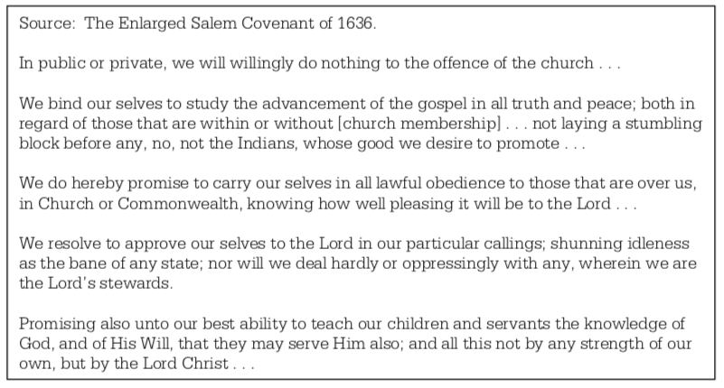

Document B
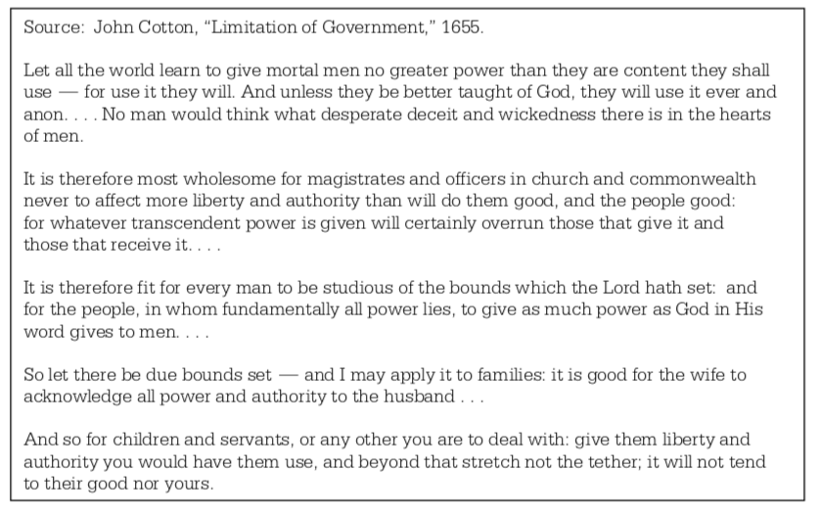

Document C
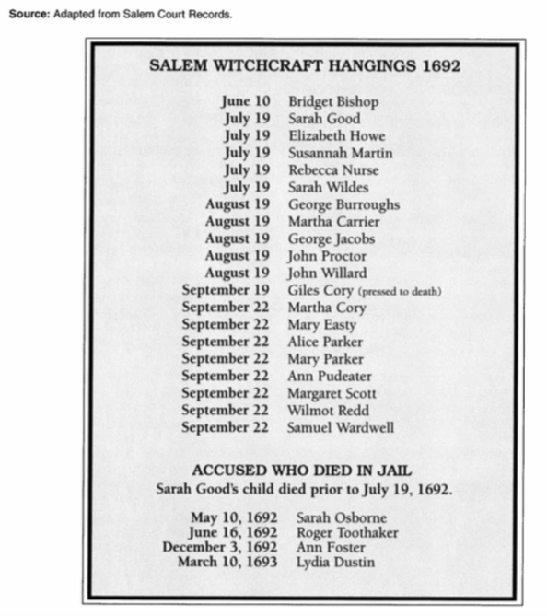
Document D
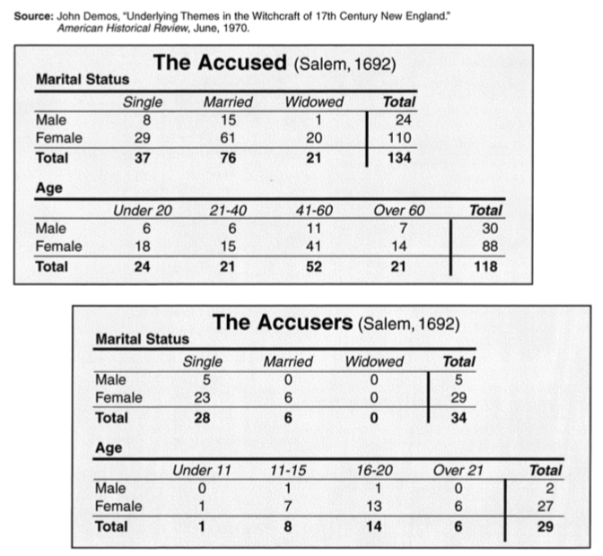
Document E
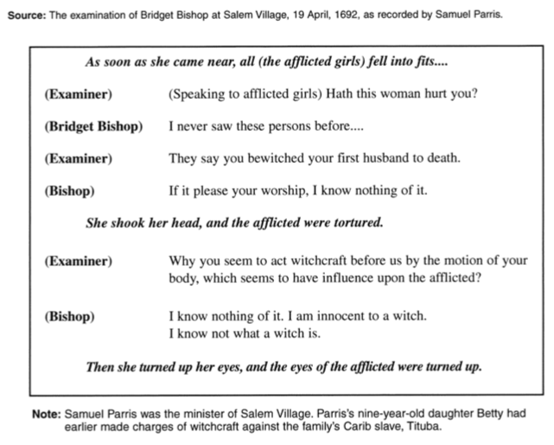

Document F
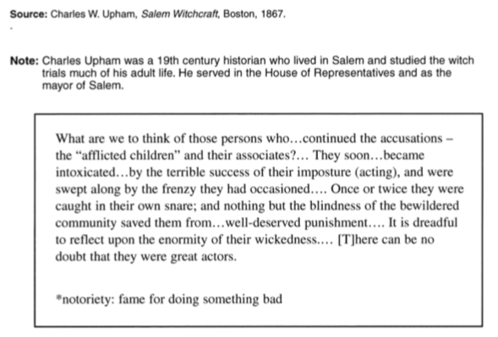
Document G

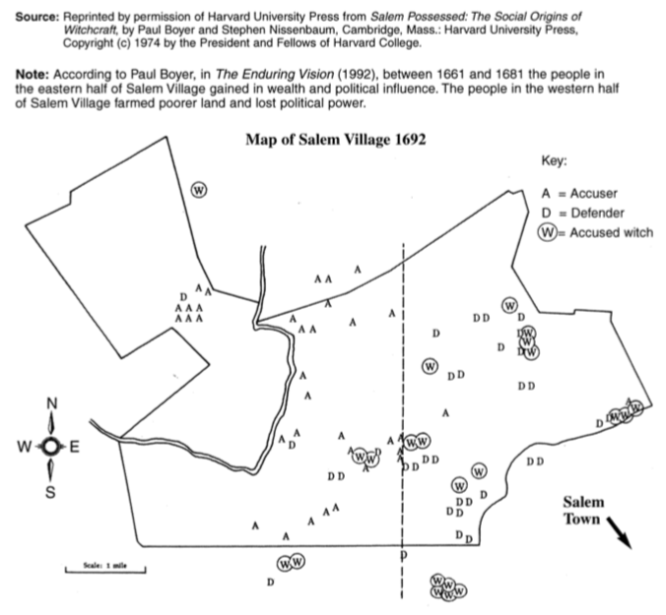

Document H

Hundreds of people were brought to trial for witchcraft in 1692, and the legal system in Salem did not give the defendants the same rights as they have today. 6 People could be convicted on spectral evidence, meaning that if someone claimed to have been attacked by your specter, or ghost, you would end up in jail. Also, evidence that presentday courtrooms normally ignore, such as hearsay, gossip, surmises, and unproven assertions, were taken into consideration in colonial America. To make matters even worse for defendants in Salem, accused witches could not call upon witnesses to testify on their behalf, nor could they seek legal counsel. Convicted witches also had no way to appeal the court’s decision. 7

Asa K. Leventha, Historian, 2015

