Which President practiced the best foreign policy?
Roosevelt, Taft, Wilson (1901-1917)

Document A
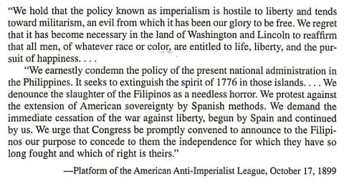

Document B
Source: Manhood and Foreign Policy Speech, Theodore Roosevelt, 1899

"…No triumph of peace is quite so great as the supreme triumphs of war. The
courage of the soldier, the courage of the statesman who had to meet storms which
can be quelled only by soldierly qualities -- this stands higher than any quality called
out merely in time of peace…we feel that no national life is worth having if the nation
is not willing, when the need shall arise, to stake everything on the supreme
arbitrament of war, and to pour out its blood, its treasure, and its tears like water,
rather than submit to the loss of honor and renown."

Document C
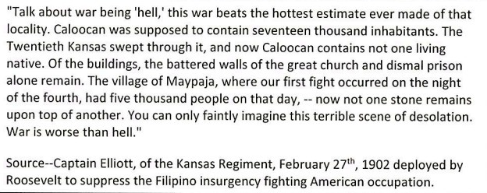

Document D
Source: Source: Theodore Roosevelt, Annual Message to Congress, Dec 6, 1904

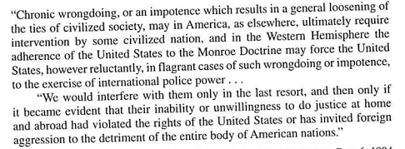

Document E
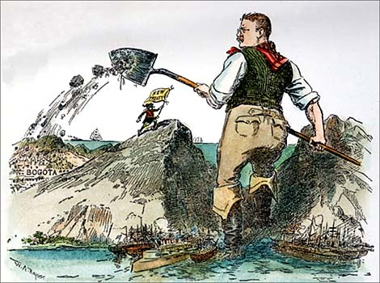

Document F
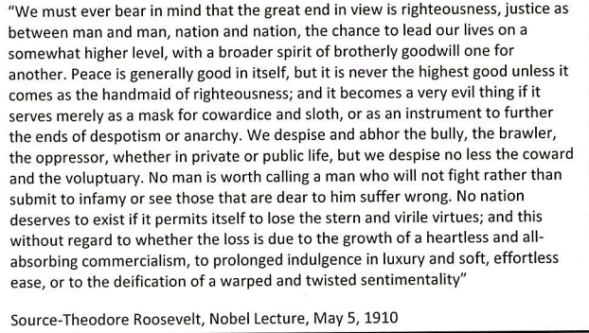

Document G
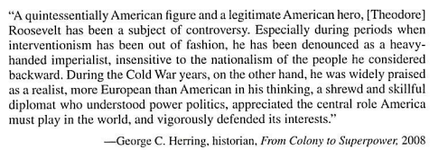

Document H Document I
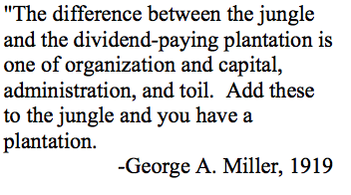 | 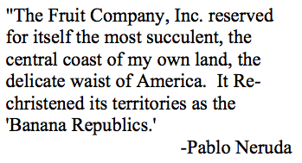

Document J Document K
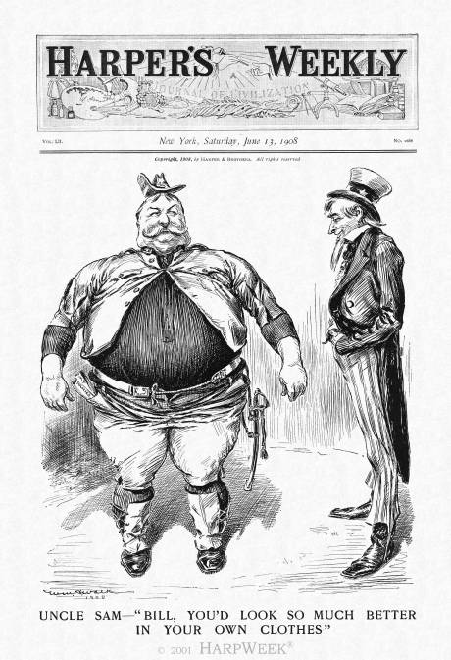  Uncle Sam – “Bill, you’d look so much better in your own clothes”  Source: Harper's Weekly featured a cartoon about the presidential election of 1908 | 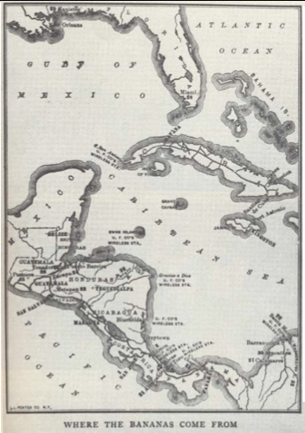  Where the Bananas Come From

Document L
Source: US Department of State, Papers Relating to Foreign Affairs, 1912
In Central America the aim has been to help such countries as Nicaragua and Honduras to help themselves. They are the immediate beneficiaries. The national benefit to the United States is twofold. First, it is obvious that the Monroe Doctrine is more vital in the neighborhood of the Panama Canal and the zone of the Caribbean than anywhere else. There, too, the maintenance of that doctrine falls most heavily upon the United States. It is therefore essential that the countries within that sphere shall be removed from the jeopardy involved by heavy foreign debt and chaotic national finances and from the ever present danger of international complications due to disorder at home. Hence, the United States has been glad to encourage and support American bankers who were willing to lend a helping hand to the financial rehabilitation of such countries because this financial rehabilitation and the protection of their customhouses from being the prey of would-be dictators would remove at one stroke the menace of foreign creditors and the menace of revolutionary disorder.

Document M
Source: William Howard Taft, U.S., Department of State, Papers Relating to Foreign Affairs, 1912

"The tremendous growth of the export trade of the United States has already made that trade a very real factor in the industrial and commercial prosperity of the country. With the development of our industries, the foreign commerce of the United States must rapidly become a still more essential factor in its economic welfare... The diplomacy of the present administration has sought to respond to modern ideas of commercial intercourse. This policy has been characterized as substituting dollars for bullets. It is one that appeals alike to idealistic humanitarian sentiments, to the dictates of sound policy and strategy, and to legitimate commercial aims. It is an effort frankly directed to the increase of American trade upon the axiomatic principle that the government of the United States shall extend all proper support to every legitimate and beneficial American enterprise abroad."

Document N
Source: The Jones Law of 1916
Whereas it was never the intention of the people of United States in the incipiency of the war with Spain to make it a war of conquest or for territorial aggrandizement; and
Whereas it is, as it has always been, the purpose of the people of the United States to withdraw their sovereignty over Philippine Islands and to recognize their independence as soon as a stable government can be established therein; and
Whereas for the speedy accomplishment of such purpose it is desirable to place in the hands of the people of the Philippines as large a control of their domestic affairs [in order that] they may be the better prepared to fully assume the responsibilities and enjoy all the privileges of complete independence: Therefore

Document O Document P
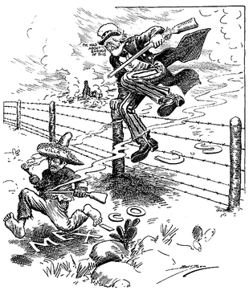 | 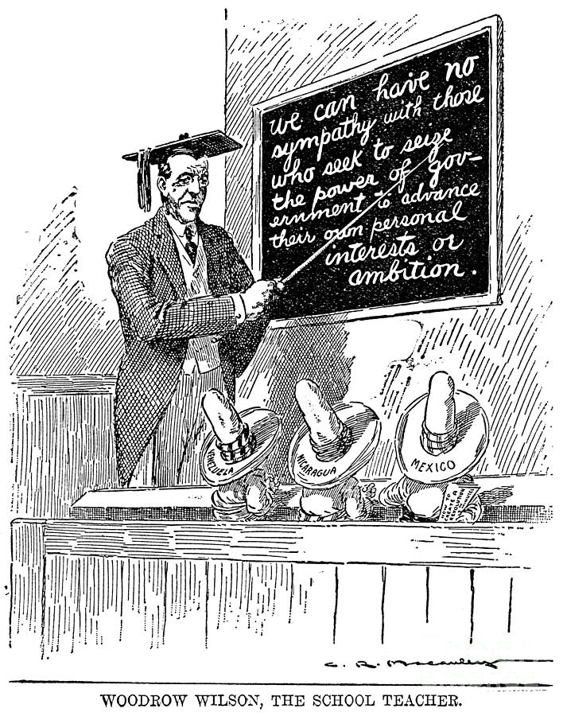

Document Q
Source: Woodrow Wilson, Address Before the Southern Commercial Congress in Mobile, Alabama, 1913

"These States lying to the south of us, which have always been our neighbors, will now be drawn closer to us by innumerable ties, and I hope, chief of all, by the tie of a common understanding of each other. Interest does not tie nations together; it sometimes separates them. But sympathy and understanding does unite them[.] ...We must prove ourselves their friends and champions upon the terms of equality and honor... We must show ourselves friends by comprehending their interest, whether it squares with our own interest or not. It is a very perilous thing to determine the foreign policy of a nation in the terms of material interest. It not only is unfair to those with whom you are dealing, but it is degrading as regards your own actions."

Document R
Source: Woodrow Wilson, Message to Congress, 1914

I venture, therefore, my fellow countrymen, to speak a solemn word of warning to you against that deepest, most subtle, most essential breach of neutrality which may spring out of partisanship, out of passionately taking sides. The United States must be neutral in fact, as well as in name, during these days that are to try men's souls. We must be impartial in thought, as well as action, must put a curb upon our sentiments, as well as upon every transaction that might be construed as a preference of one party to the struggle before another.

Document S
Source: Woodrow Wilson, Joint Address to Congress Leading to a Declaration of War Against Germany, 1917

But the right is more precious than peace, and we shall fight for the things which we have always carried nearest our hearts,-for democracy, for the right of those who submit to authority to have a voice in their own Governments, for the rights and liberties of small nations, for a universal dominion of right by such a concert of free peoples as shall bring peace and safety to all nations and make the world itself at last free.

Document T
Source: Woodrow Wilson, Peace without victory Speech, 1917
…The terms of the immediate peace agreed upon will determine whether it is a peace for which such a guarantee can be secured. The question upon which the whole future peace and policy of the world depends is this: Is the present war a struggle for a just and secure peace, or only for a new balance of power? If it be only a struggle for a new balance of power, who will guarantee, who can guarantee the stable equilibrium of the new arrangement? Only a tranquil Europe can be a stable Europe. There must be, not a balance of power but a community power; not organized rivalries but a organized, common peace….

Document U


